**1.Home page of this application will give the list of existing tickets.Now the list is empty.To add a ticket click on “New Ticket”.**

**Ticket Tracker Application.**

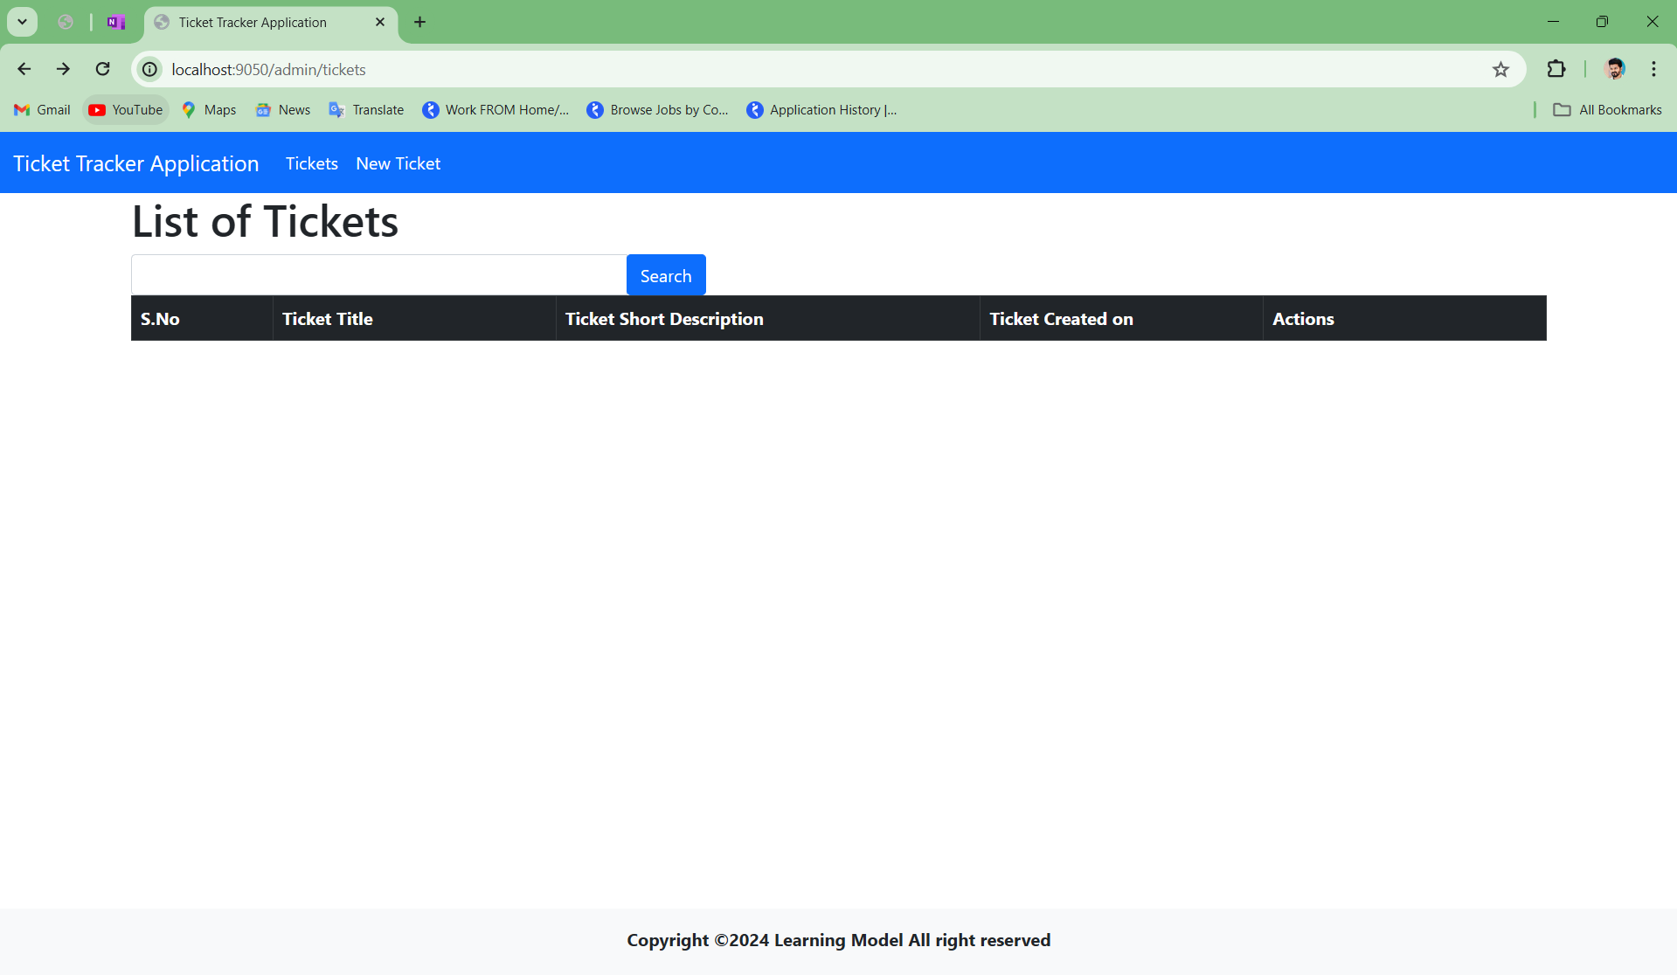

****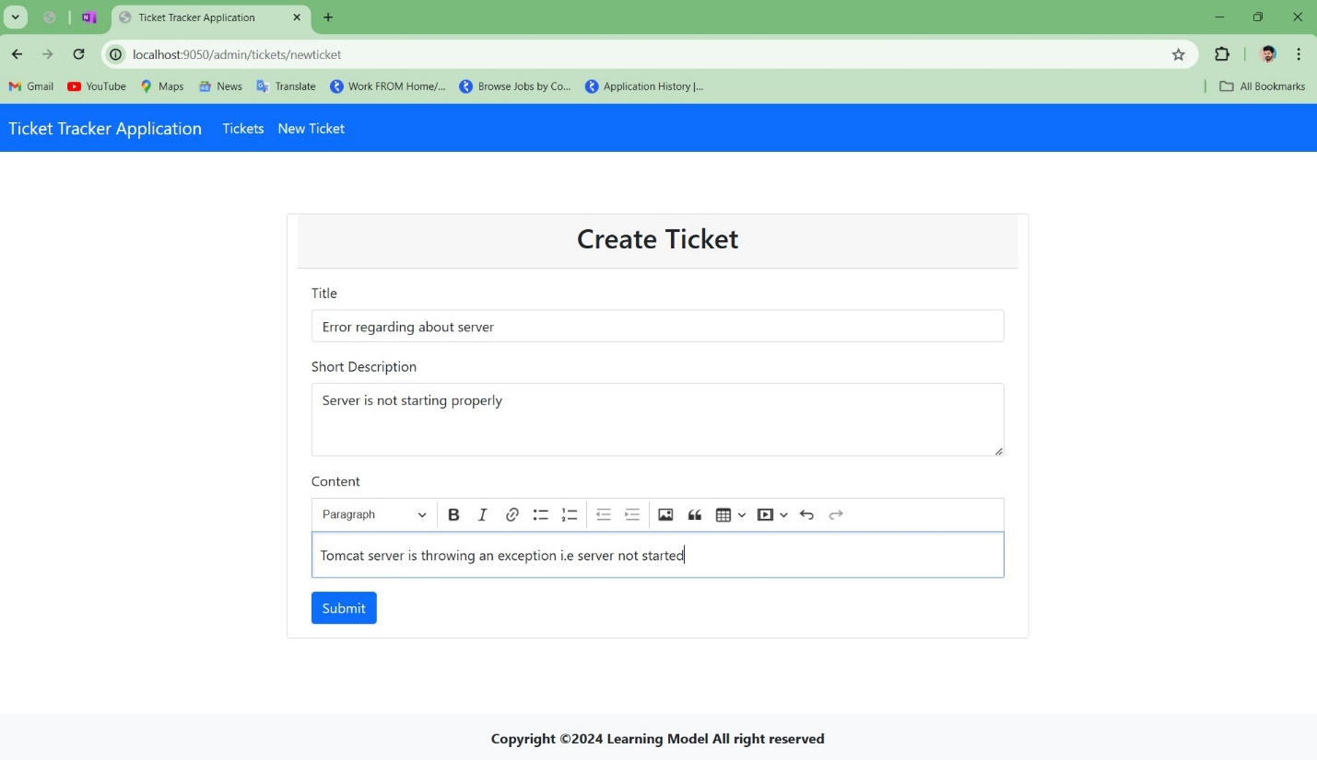

**2.Now the create ticket form is shown in the browser after clicking on “New Ticket”.Here we are inserting some dummy data.After submitting the from will redirect to the “List of Tickets”.**

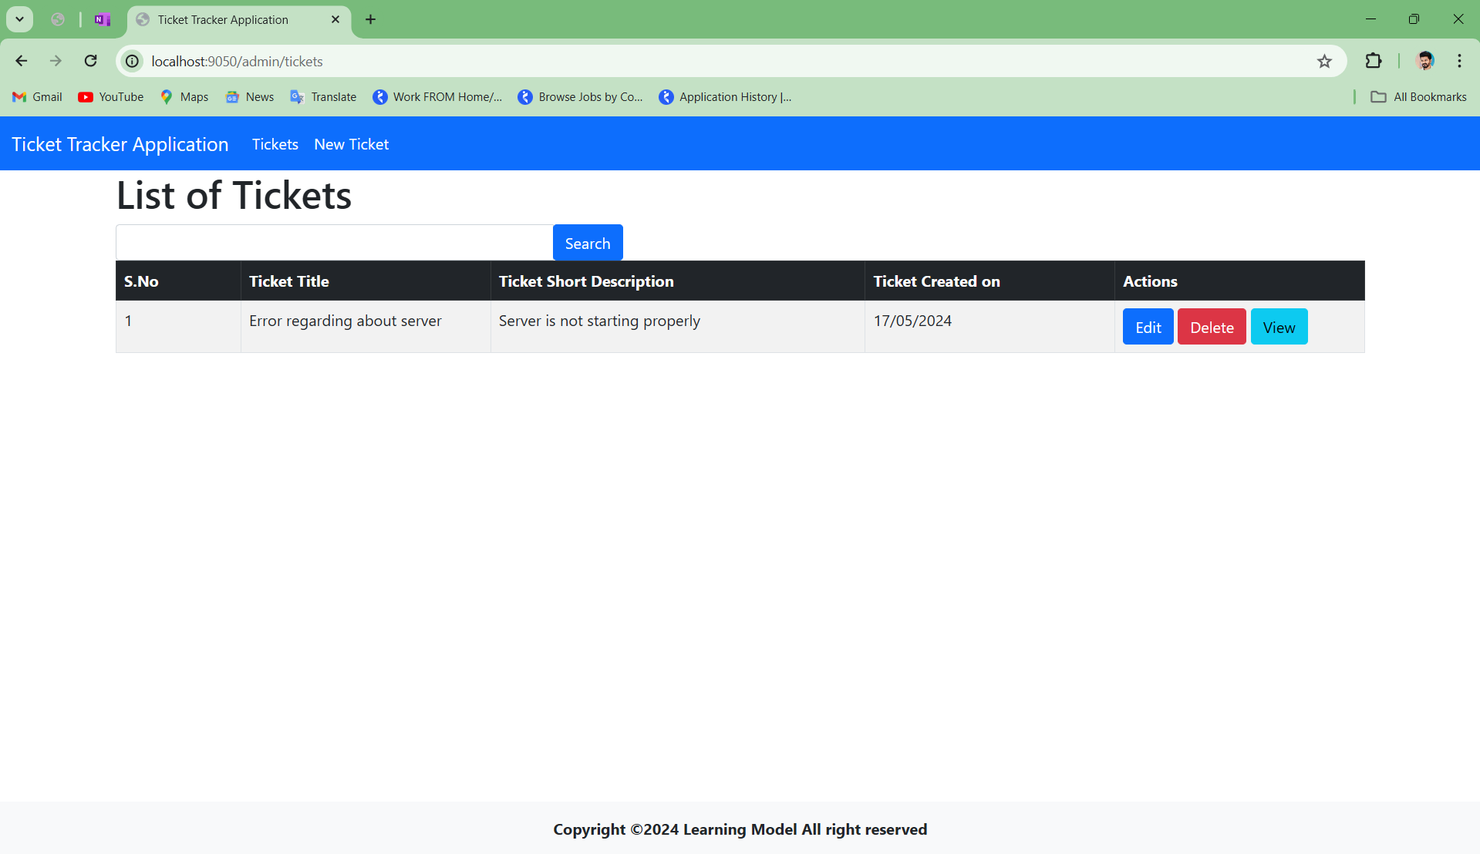

**3. Now the new ticket is added to the list.Again let’s add two more ticktes to the list.To add ticket click on “New Ticket”**

****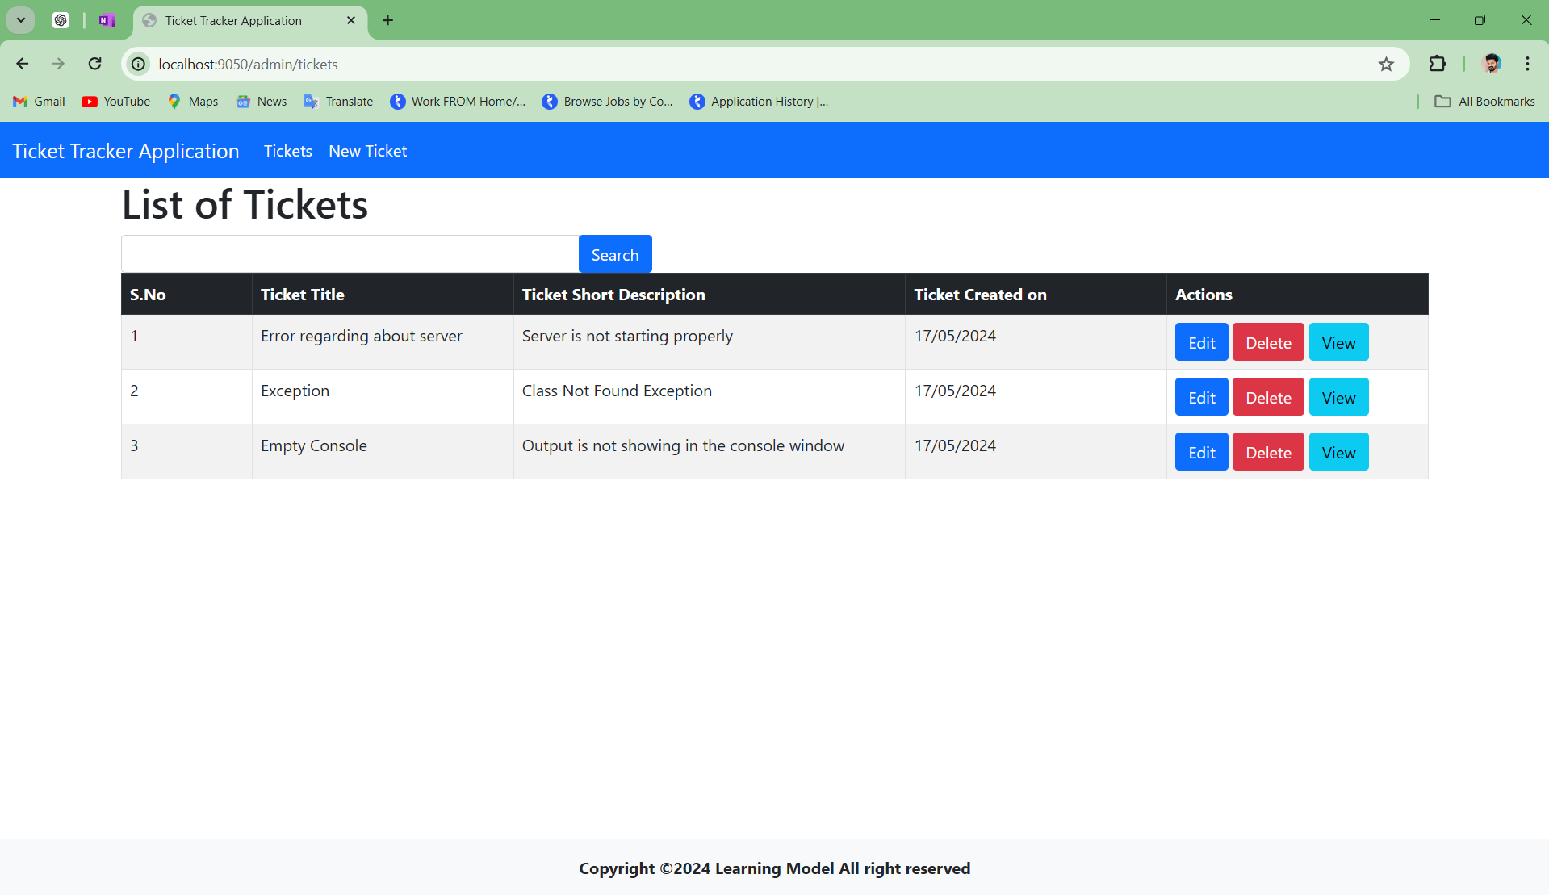

**4. After adding tickets now the updated list will be shown below. Now let’s “View” the existing ticket.To get the read the ticket click on “View” ,it will give details and contents about the tickets.**

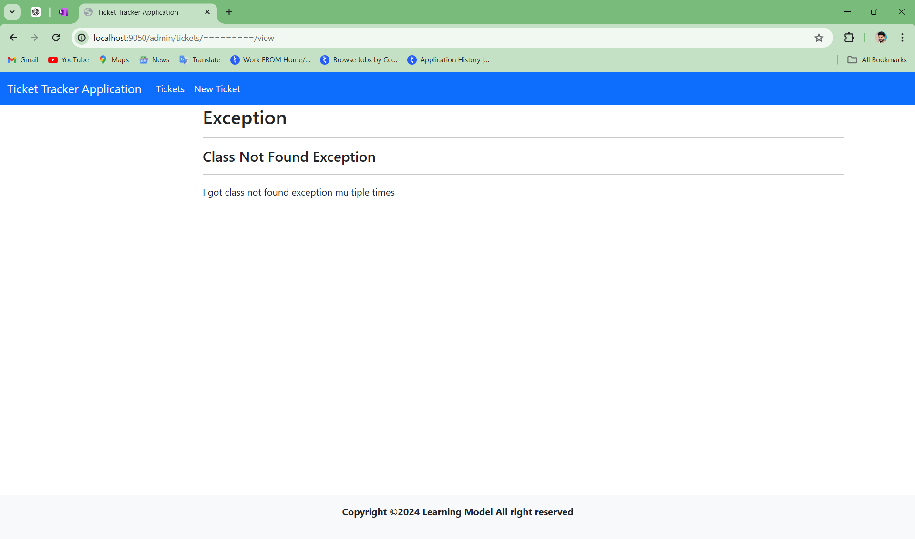

**5.Now the below image showing details of ticket.Here we can only have the details the tickets.To get back to the list Click on ”Tickets”.**



**6.Now the “Edit” function to edit the ticket click on “Edit” button which is provided. It will take you to the “Edit Ticket” form.**

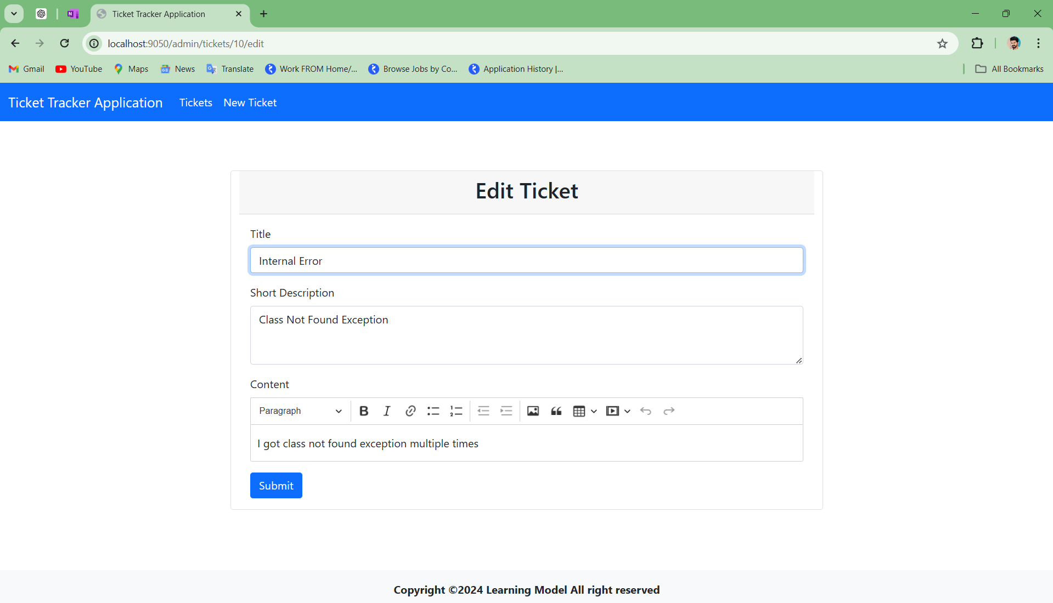

**7.Now we are in edit form.We are editing the second ticket which of S.No.2. We will edit ticket title to “Internal Error” which is earlier as ”Exception”. To save this update click on “Submit” button.It will take you to the “List Of Ticket”.**

****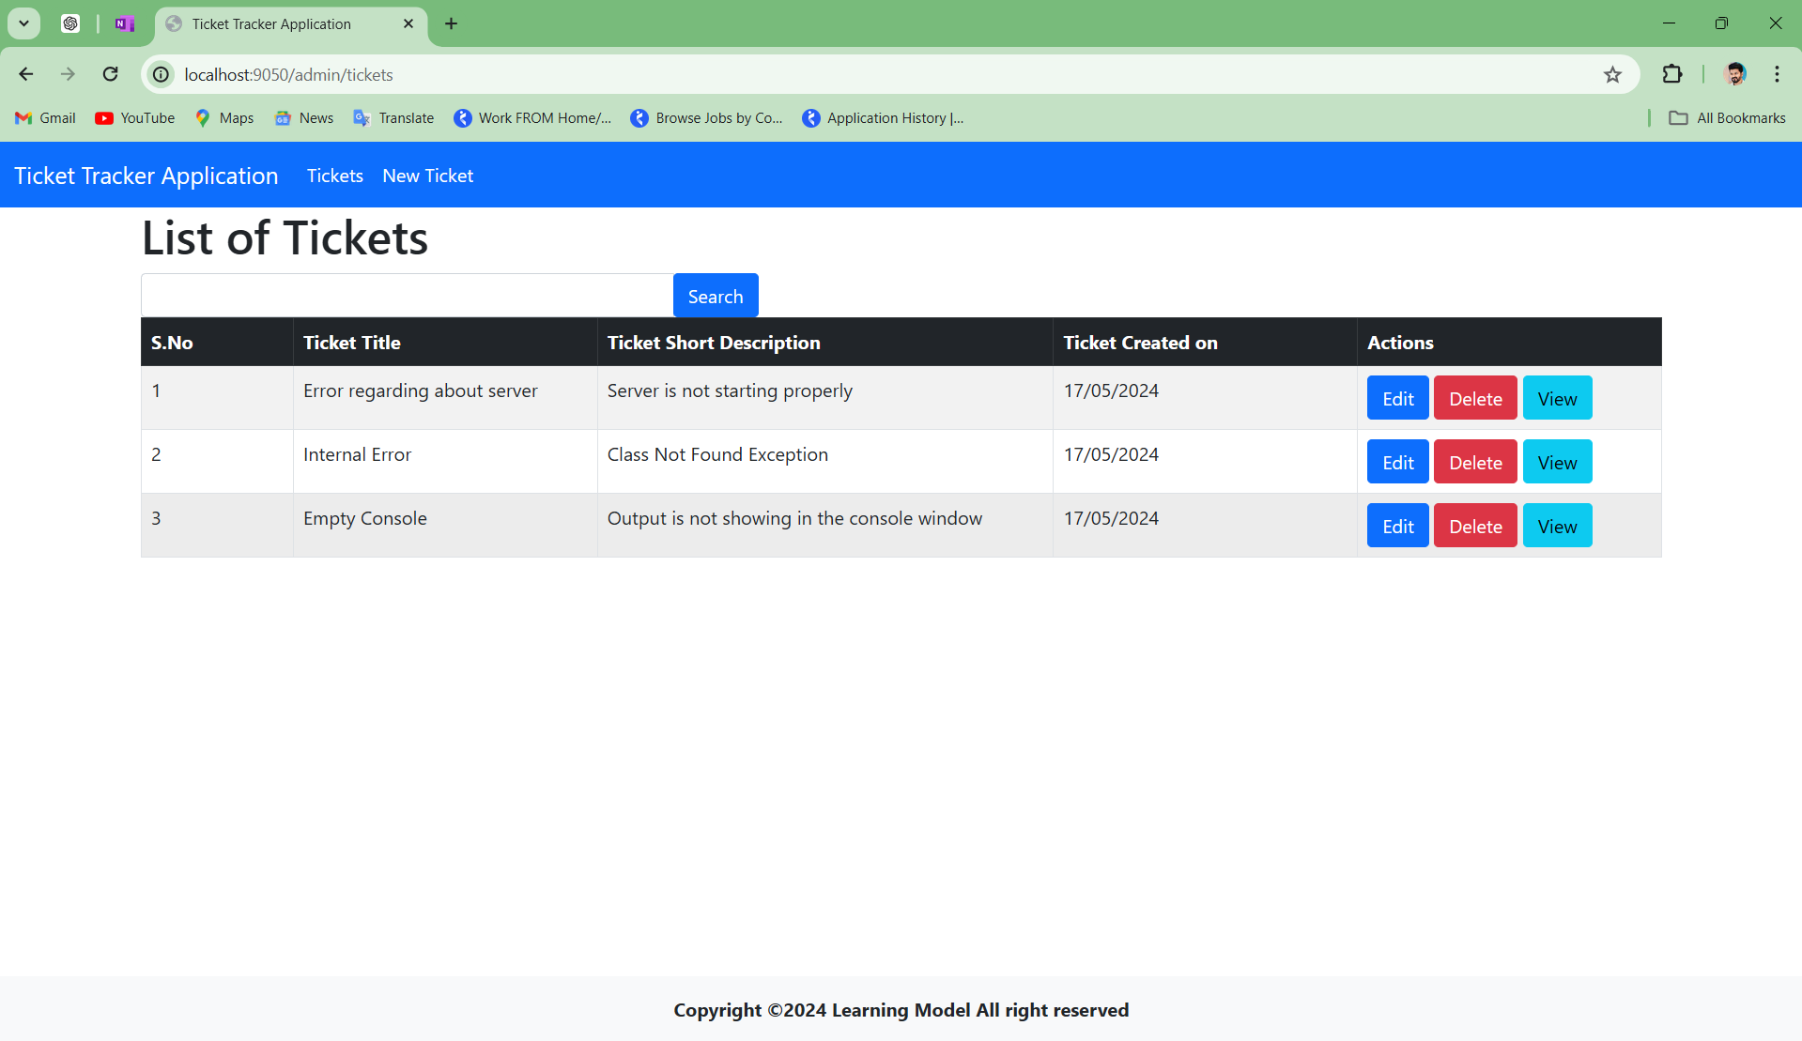

**8.Now here we got the updated ticket list. Here we can observe the ticket of S.No.2 , title is updated now.**

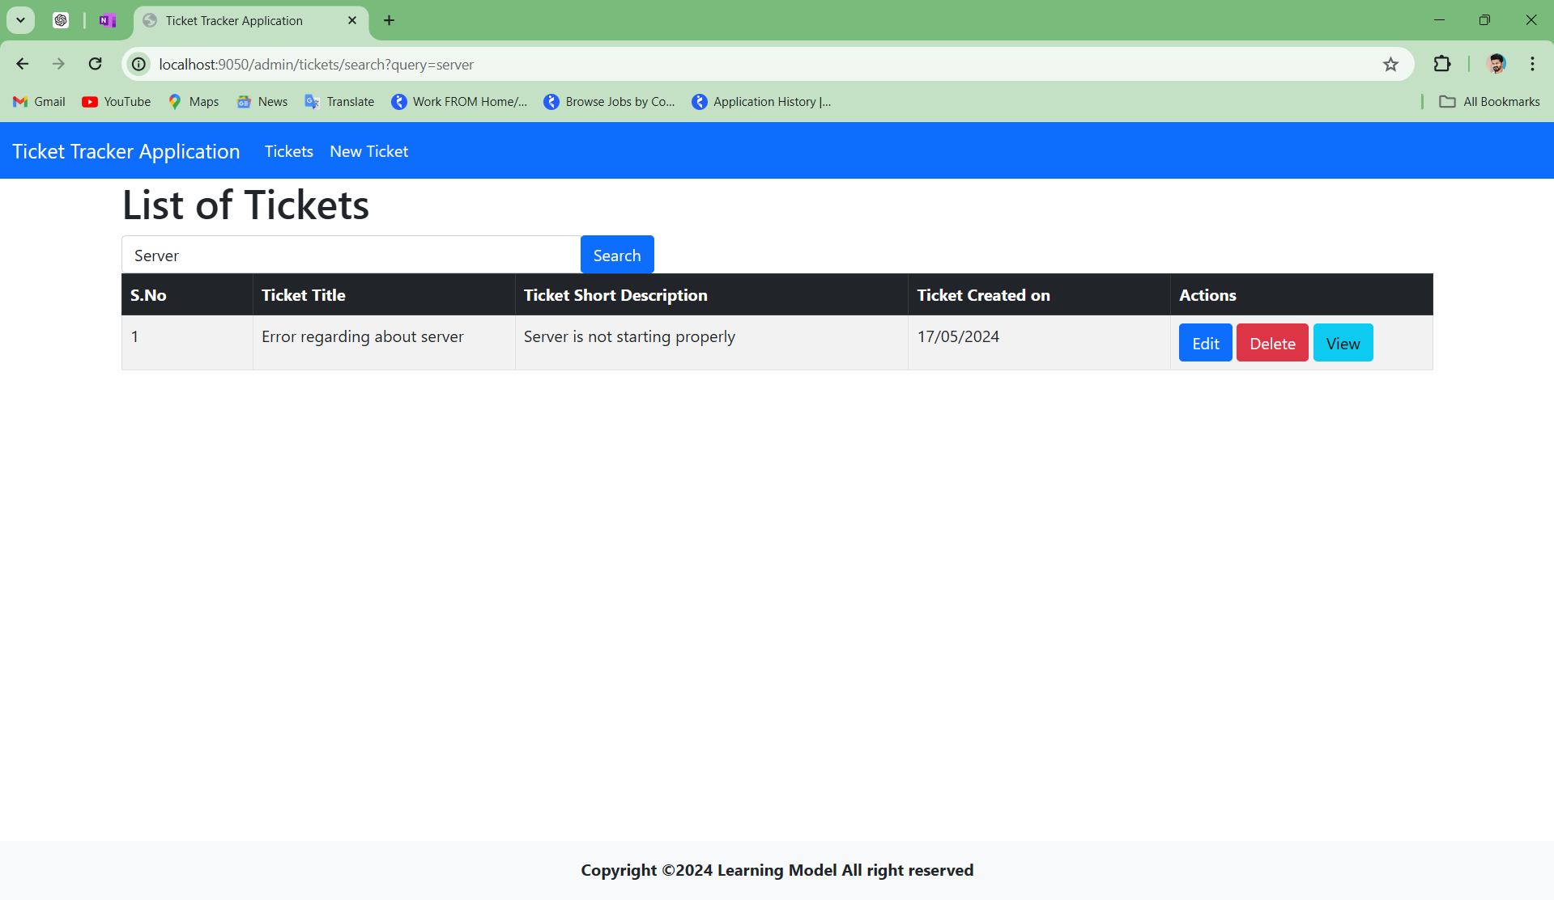

**9.Now let’s search the particular ticket which we want. We can see we have search bar below the navigation bar. In the search bar we are searching ticket name “Server”.The tickets which have word “Server” will be shown in the list**



**10.Now we will see the “Delete” function.In the below Image we have list of tickets, in that we have three records.Let’s delete one record, to delete any record click on “Delete” button.**

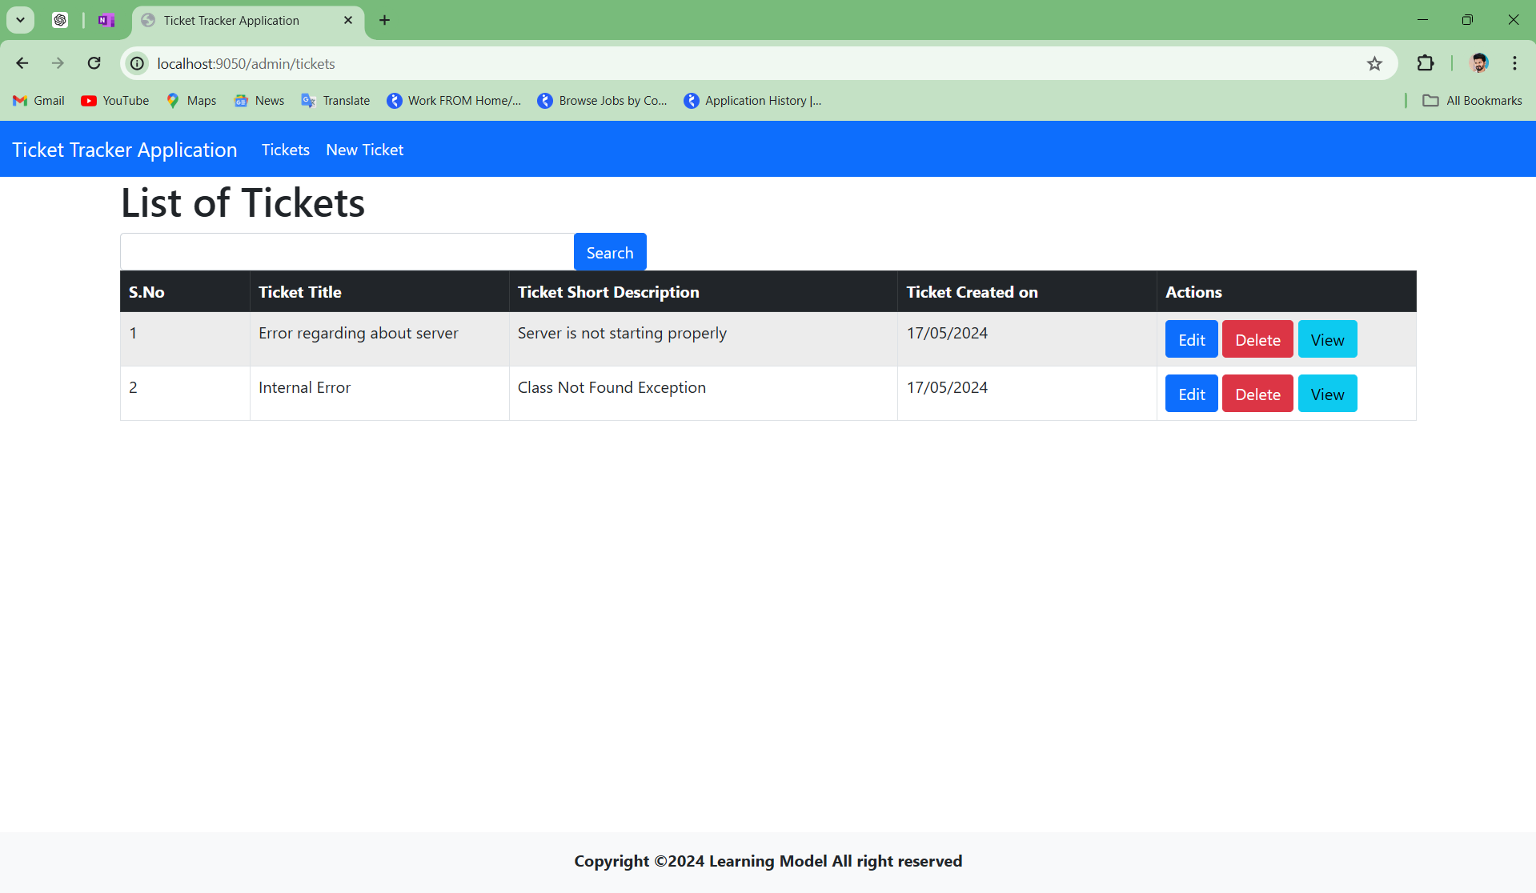

**10.Now we got the updated list of tickets after deleting a record from the list.**

**Thank You**